CATS Shuttle
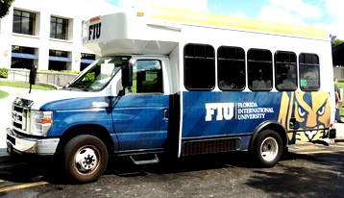
The CATS shuttle is a free service from the Modesto A. Maidique Campus to the College of Engineering and Computing located on 107th Avenue and Flagler Street. There is no charge for this service.
We are doing our part to save the environment with Biodiesel buses.
EFFECTIVE: Fall & Spring Semester Schedule
GC Bus Stop | PG5 Bus Stop | Engineering Campus  Bus Stop
6:15 AM | 6:20 AM | 6:55 AM
7:15 AM | 7:20 AM | 7:55 AM
8:15 AM | 8:20 AM | 8:55 AM
9:15 AM | 9:20 AM | 9:55 AM
10:15 AM | 10:20 AM | 10:55 AM
11:15 AM | 11:20 AM | 11:55 AM
12:15 PM | 12:20 PM | 12:55 PM
1:15 PM | 1:20 PM | 1:55 PM
2:15 PM | 2:20 PM | 2:55 PM
3:15 PM | 3:20 PM | 3:55 PM
4:15 PM | 4:20 PM | 4:55 PM
5:15 PM | 5:20 PM | 5:55 PM
6:15 PM | 6:20 PM | 6:55 PM
7:25 PM | 7:30 PM | 7:55 PM
8:25 PM | 8:30 PM | 8:45 PM
9:25 PM | 9:30 PM | 9:45 PM
10:00 PM | 10:05 PM | 10:20 PM

